Task Order for
GEHC SDT ("Smart Dispatch Tool")

Task Order Effective Date: November 14 2016
Task Order Completion Date: November 30, 2017

This Task Order (“TO”) is made by and between GEHC a division of General Electric Company (“GE” or “Client”) and Capgemini America, Inc., as a successor in interest to Capgemini U.S., LLC (“Capgemini” or "Contractor"), and is subject to and made a part of the GDC Master Services Agreement by and between General Electric International, Inc. and Capgemini America, Inc., as a successor in interest to Capgemini U.S., LLC, with an Effective Date of January 1, 2013 (the "Agreement). All capitalized terms used in this Task Order are as defined in the Agreement, unless otherwise expressly defined herein.

1. Scope of Project:

General Description: The objective of this engagement is for Capgemini to provide Application Support and Development services for GEHC SDT application, with the following offshore resources:
- Capgemini proposes the following core team:
  - A team size of four (4) Runtime Support (RTS) team members based offshore (India) to provide 15*5 supports. i.e. 1:30AM IST to 04:30PM IST (Pool of resources provide supports from Bangalore and Mumbai Offshore location)
  - A team of five (5) developers based offshore (India) to develop the enhancements of upcoming releases.
  - A team size of three (3) Validation testers to perform validation testing.
- Release Manager [RM] for Development Operations [DevOps] release management activities.
- Project Manager [PM] for Project management activities.
- Offshore based Business Analyst [BA] for Requirement gathering and analysis

Task Order Delivery Locations
Locations where Contractor will provide the Services: Low Cost Country: India, Contractor location Onshore: NA_ GEHC location
Nearshore: NA GDC location
The pool of resources will be maintained at Capgemini’s offices in Bangalore and Mumbai location for support, in case of any disaster team can support from other location wherein BCP(Business continuity plan) in place.

Definitions
Abbreviations | Meaning
BRM | Business Relationship Manager
ERP | Enterprise Resource Planning
FMEA | Failure Modes and Effects Analysis
SSO | Single Sign On
PM | Program Manager
SPR | System Problem Report
User | Any employee, agent and/or contractor of GEHC
SLA | Service Level Agreement
RM | Release Manager
PM | Project Manager

GEHC's responsibilities, if any, include the following: Third Party Software
Any Third Party Software provided by GEHC must be procured by Contractor via the GEHC Global Software Compliance process: http://supportcentral .qe.com/products/sup products.asp?prod i d=60503

Description of Services: In Scope
Application Support and Development needs to be carried out for the tasks stated below:

- Activities related to the SDT APAC Web Application for Production Support

        - Application Support and Monitoring
        - Triage coordination ownership
        - Ticket follow up management
        - Escalation management
        - Basic trouble shooting
        - Repeatable Ticket Resolution
        - Detailed research
        - Problem Management
        - Root Cause Analysis
        - Bug Fixes, process execution and testing
        - Support SLA metrics
        - Regular status update to users
        - Manage future changes
        - Change control management
        - Deploy monitoring mechanisms
        - Middleware (MW) coordination between the interfaces
        - Application protocol interface (API) coordination between the interfaces
        - Visual Planning Tool (VPT) tool enhancement and modifications
        - Weekly master data load between SDT application, TRACE application and CLICK software.

- Activities related to the SDT APAC Web Application for Development

        - Understand the Requirements
        - Coding
        - Unit Testing
        - Validation testing, Script execution in lower environments, Regression testing and Documentation.

Support Request Process flow:

The diagram below depicts the support ticket process:

Process
Output
Arrival of ticket in service now
Problem reported through phone or email
Infra team to resolve the issue
Siebel CRM team to resolve the issue
SMAX team to resolve the issue
Team Lead allocate the ticket to the Team member or Team member proactively takes responsibility of the ticket
Create a ticket in service now
Analyze the given problem and confirm the existence of the problem
Report the issue as non-application issue and close the ticket
Once the problem is resolved with user approval and then ticket is closed
TM sets the status to active
Forward the ticket to Infra team and track it to closure
Forward the ticket to Siebel team and track it to closure
Forward the ticket to SMAX team and track it to closure
Identify the cause of the problem and provide a fix
Close the ticket monitoring following fields, close code, was the incident caused by change, was the incident resolved by the change, and close notes
Lower the priority of the ticket when there’s a long wait for user’s response to the call made by us
Contact users for more information required on the problem (Leave the voice mail if the user is not available)
If need be, contact related application’s team member to get more details which are out of scope
Infra related
Siebel CRM related
SMAX/Trace related
Application related
No
Yes
No
No
No
Yes
Yes
Yes
Independent Capgemini activity
Indicates dependency on GE/Other team for completion of activity. Capgemini team will coordinate with dependent teams and track it closure

Development Execution Model:

Below table depicts about the flex ramp up and down of resources based on the parameters defined:

Parameters | Is Ramp up/down Required | Ramp up/down time
Estimation=Capacity | No | NA
Estimation=+/-10% Capacity | No, We will leverage the  Support team. | NA
Estimation>10% Capacity | Yes (Ramp up) | 4 Weeks
Estimation<10% Capacity | Yes (Ramp down) | 2 Weeks
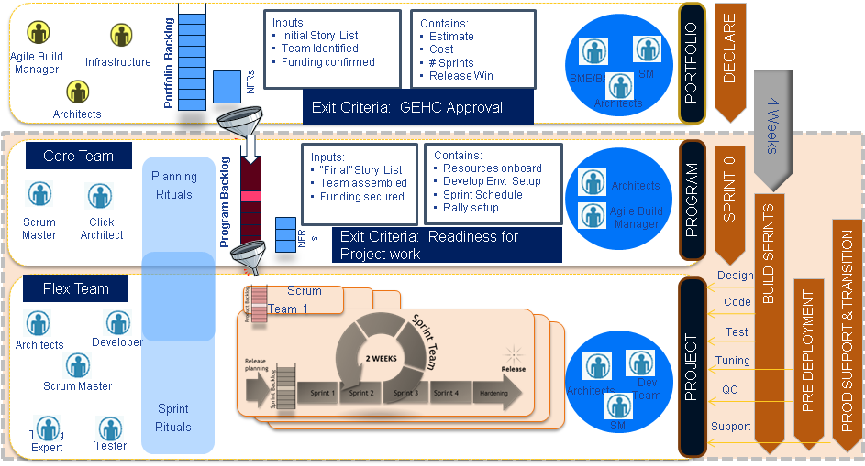

Assumptions and Dependencies:

Following are the assumptions made by Capgemini. Any variations in these assumptions may impact cost and schedule of the Project.

- We are not modifying the application other than Smart Dispatch Tool (SDT) and Visual Planning Tool (VPT).

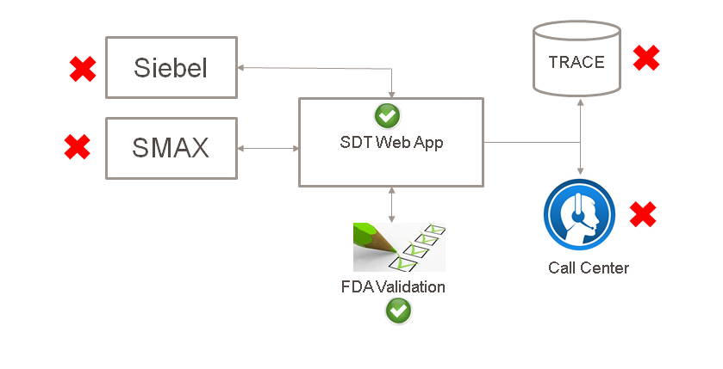
- Capgemini Offshore Team will work during the business working days to provide the 15*5 support i.e. 1:30AM IST to 04:30PM IST (Pool of resources provide supports from Bangalore and Mumbai location)
- The required core skills of the developers are application support and monitoring. Any change in the required skills will call for change control mechanism to ensure quality services to GEHC Any change in the skills will call for change control mechanism to ensure quality services to GEHC
- Limited support (one FTE on call) will be provided during India public holidays.

Change Management:

- Any increase in the scope stated in the In-scope section above will impact the effort /price, and shall be handled as per Change Management Procedure.
- GEHC shall provide VPN access to the development and Production environments, as required - based on work assigned.
- The required core skills of the developers are application support and monitoring. Any change in the required skills will call for change control mechanism to ensure quality services to GEHC.
- Any change in start date will change end date of the project accordingly.
- Capgemini PM will work with GEHC PM for surge in unplanned work and on the agreement of resource estimation, Resource ramp up/down will be planned in lead time of 4 weeks.

Application Support:

- GEHC team will provide knowledge transition on the applications.
- GEHC will provide all required support accounts and tools necessary to execute the tasks.
- GEHC will ensure availability of approved documents before acting on the tickets.
- Development team SPOC/Functional owner available during Startup phase.
- Tech Lead/Functional owner from Capgemini and GE to analyze the given problem and confirm the existence of the problem.
- Application support team is expected to work only on in scope tickets and forward the ticket that is out of scope to respective group and track it to closure.
- All software licenses for this engagement will be provided by GEHC.

Solution related:

- GEHC shall nominate a single point of contact (SPOC) for the project through whom all communication shall be made.
- There will be on-going support from Functional Owners from GE during the engagement.

Security related:

- GE needs to perform security testing like Static application security testing (SAST) and Dynamic application security testing (DAST).
Environment related:

Offshore resources will be located in GE’s designated Capgemini GDC offices and will have connectivity to the GE network.

Service Level Agreements:

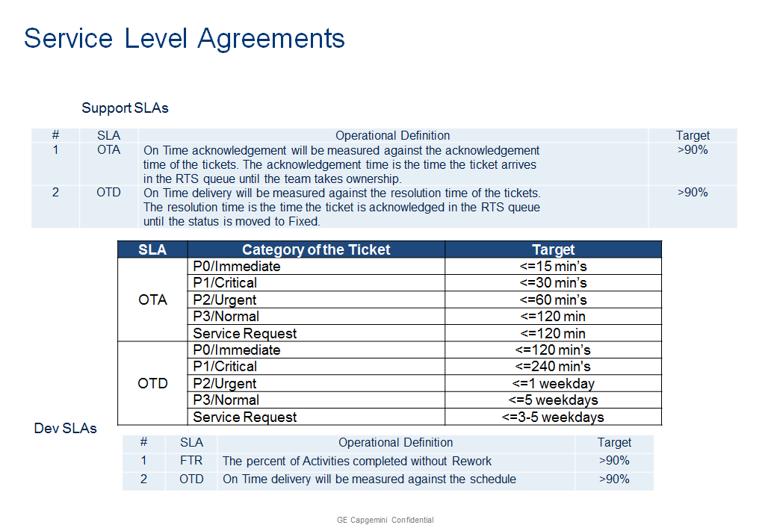

General Assumptions:

Capgemini shall have no obligation independently to verify the accuracy or completeness of the information provided by GE or its agents.

Capgemini’s services are informational and advisory in nature, and GE has full responsibility for the use of, and the results obtained from, the services and any deliverables. Capgemini is not providing GE with any legal or financial advice.

Client shall ensure that GE has the necessary authorization and consent to disclose all data, including personal data, to Capgemini and for Capgemini to perform the services contemplated in this TO.

Out of Scope:

Support to SDT application
  - Level 1 Support
  - Functional Support
Infrastructure
  - Infrastructure Support: Level 1 Helpdesk, Server Configuration and tuning, Operating System, SSO/LDAP
  - Hardware and Software installation and upgrade
  - Server Monitoring
  - Server Hardware and Network Maintenance
  - Operations Support: Database Administration, Application Server
Applications
  - Modification to other than SDT and VPT.
  - Middleware (MW) Development/Enhancement
  - Application Programming Interface (API) Development/Enhancement

- Services to be provided by Contractor include the following:

Services | Completion Date
DevOps – Application support and Development | Development- To be defined in the respective amendment.  Support – Regular ongoing application support

- Project Services Completion Dates:

This Task Order shall be a Fixed Price Task Order for the amount of US$ 552,812.40 Contractor will bill GEHC in accordance with the following schedule upon Contractor's completion and GEHC's written acceptance of the applicable Service. All amounts described in this Task Order are in USD.

Services | Completion Date | Price in US $
Monthly Support and Development of Sprint 1 & 2 | Dec/31/16 | 41,924.40
Monthly Support and Development of Sprint 3 & 4 | Jan/31/17 | 51,088.80
Monthly Support and Development of Sprint 5 & 6 | Feb/28/17 | 51,088.80
Monthly Support and Development of Sprint 7 & 8 | Mar/31/17 | 51,088.80
Monthly Support and Development of Sprint 9 & 10 | Apr/30/17 | 51,088.80
Monthly Support and Development of Sprint 11 & 12 | May/30/17 | 51,088.80
Monthly Support and Development of Sprint13 & 14 | Jun/30/17 | 51,088.80
Monthly Support and Development of Sprint 15 & 16 | Jul/31/17 | 51,088.80
Monthly Support and Development of Sprint 17 & 18 | Aug/31/17 | 51,088.80
Monthly Support and Development of Sprint 19 & 20 | Sep/30/17 | 51,088.80
Monthly Support and Development of Sprint 21 & 22 | Oct/31/17 | 51,088.80
Total |  | 552,812.40

- Project Managers

Contractor Project Manager: Saraswathi Nagaraj ; Tel.: Ext -8094070 – Mob. + 91 99 80159104
Address: 158-162(P) & 165-170(P), EPIP Phase II, Whitefield, Bangalore 560066, India.

GEHC Project Manager: Telephone:
Address: Facsimile:

IN WITNESS WHEREOF, the parties hereto have caused this Task Order to be executed by their duly authorized officers or representatives.

GEHC, a division of General Electric Capgemini America, Inc. (Contractor)
Company
.

By: ----------------------- By: ----------------------------

Name: ---------------------- Name: ------------------------

Title: ----------------------- Title: ---------------------------

Date: ----------------------- Date: -------------------------

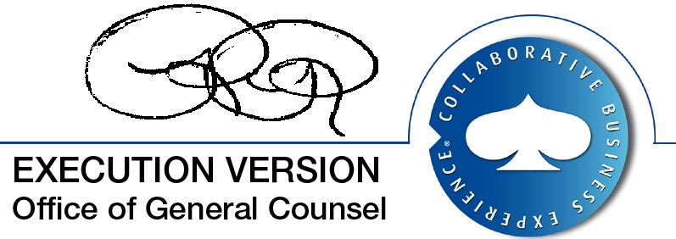
November 11, 2016

